**SKILLING 2**

**Applications on Data Analysis Process**

.CSV file link : <https://www.kaggle.com/aungpyaeap/supermarket-sales>

**In a super market XXXX selling the products such as Health and beauty, accessories, Electronic, Home and lifestyle, Food and beverages, Sports. Following analysis may be helpful to increase the sale of Shop. You are asked to analysis the supermarket data by**

1. Information/summary

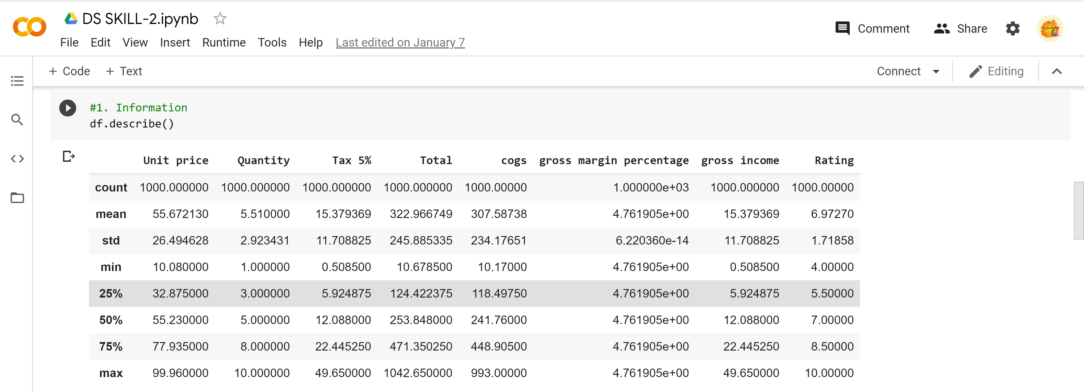

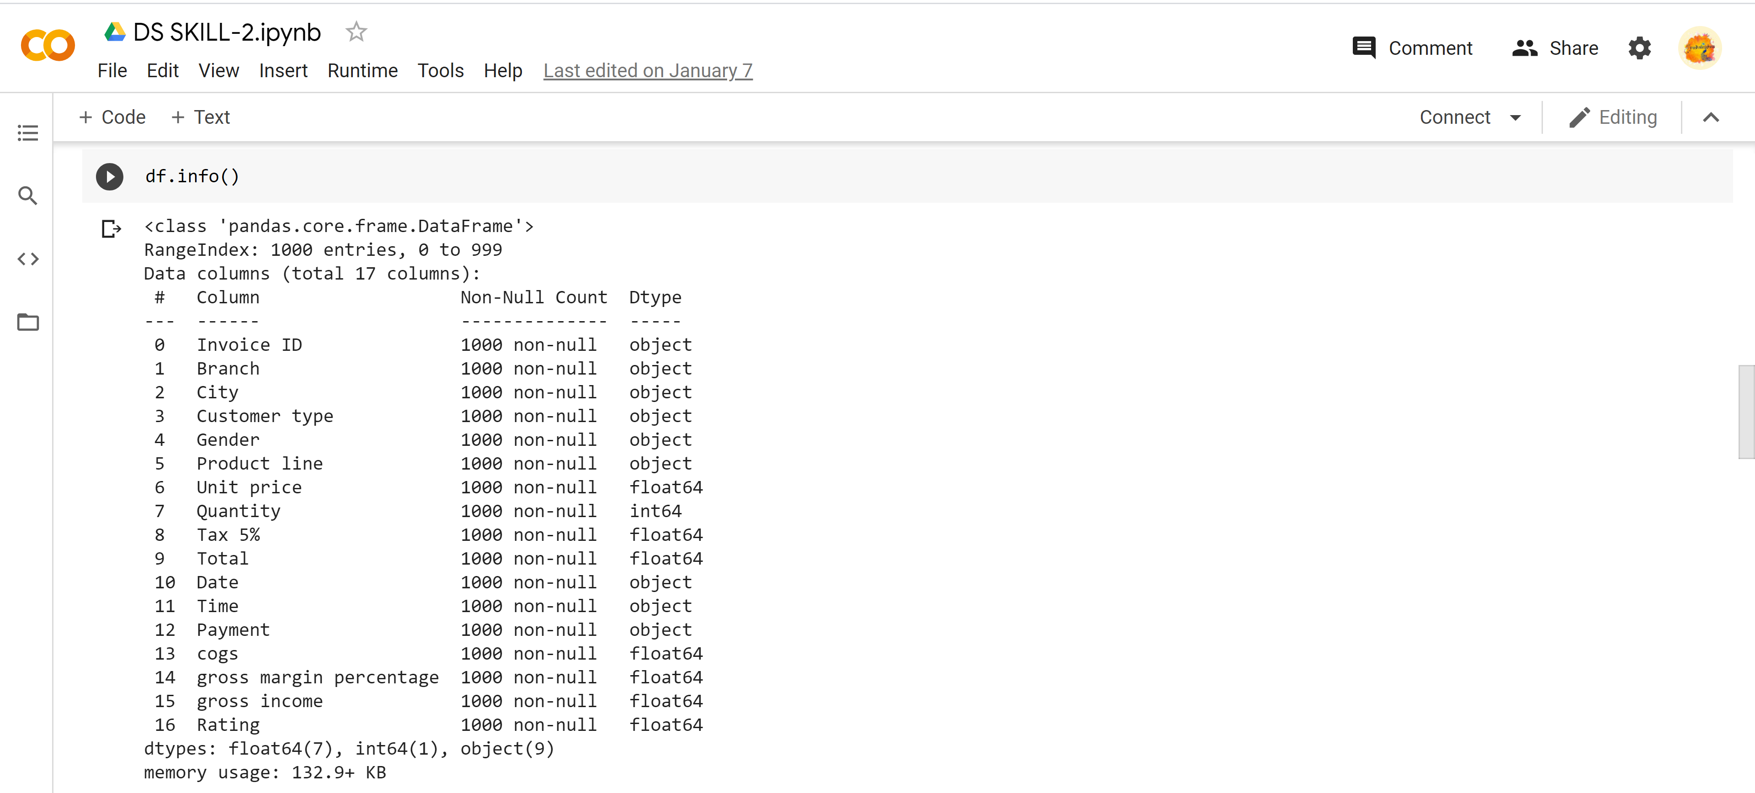

1. Mode of Health and beauty, accessories, Electronic , Home and lifestyle, Food and beverages, Sports

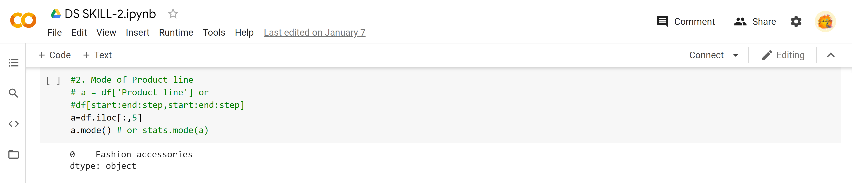

1. Mean of Health and beauty, accessories, Electronic , Home and lifestyle, Food and beverages, Sports

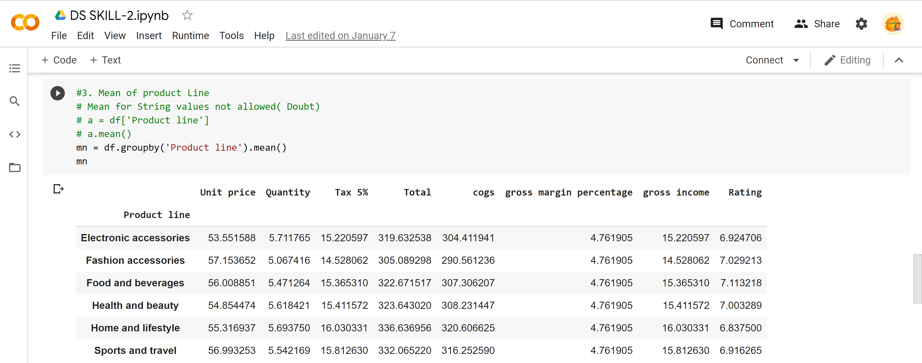

1. Standard deviation of unit price

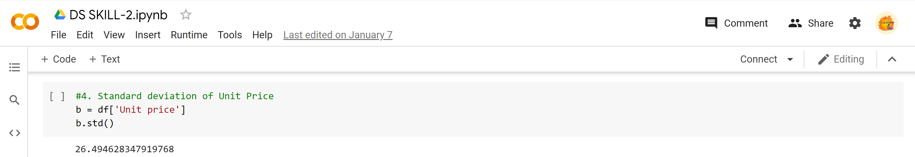

1. Total Customers, Total Females ,Total Males

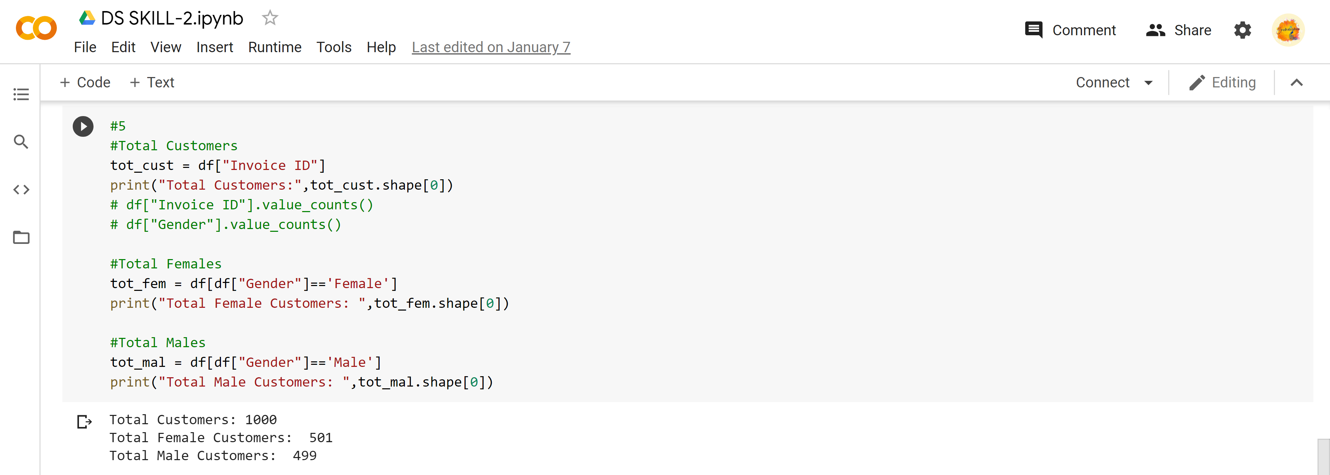

1. Maximum People pays through e-wallet

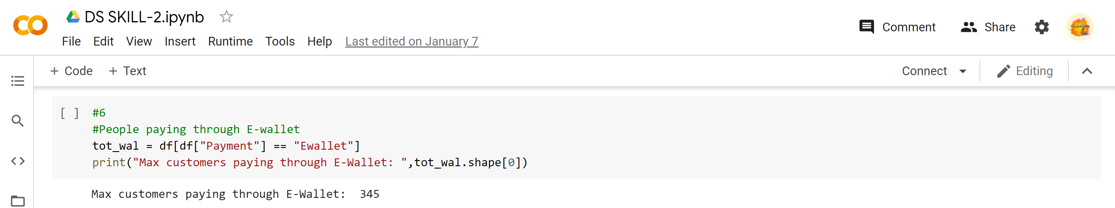

1. Maximum people comes from Yangon City

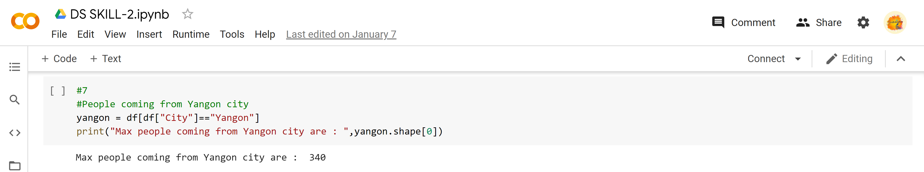

1. Max Average Sales of Fashion Accessories is from Females

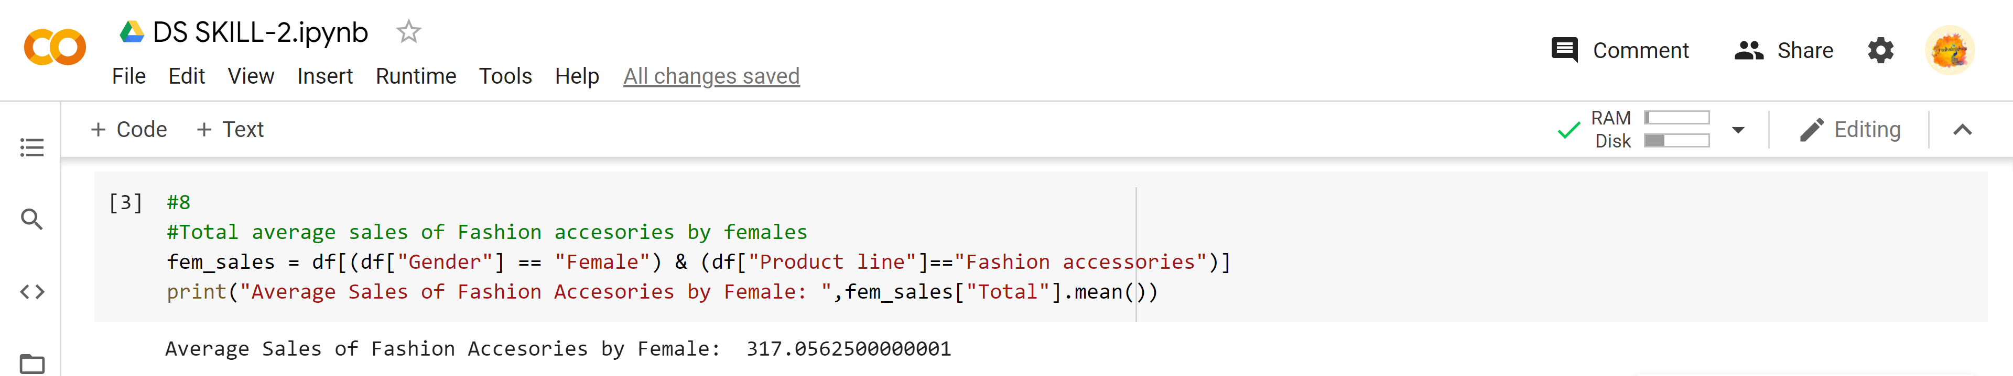

1. Max Average Sales of Health & Beauty is from Males

